Note: This document is “view only”. Please create a copy of this document and save it to your drive.

**SOP- Teamwork Backup- Systems Vault**

**PREREQUISITES**

[Master: SOP- Operations Management- Systems Vault](https://docs.google.com/document/u/0/d/1gIeHLaKTWivg43RAx2fHPd14QktmUju8dcElYWywAXM/edit)

[Teamwork PM](http://sarahnoked.com/teamwork)

Teamwork PM Admin Access

SN Teamwork Backups

**PURPOSE**

To ensure all client data is backed up and accessible.

**POLICY**There are monthly recurring tasks in [Teamwork PM](http://sarahnoked.com/teamwork) for backups

All backups are saved in Google Drive in the folder SN Teamwork Backups.

Note: You must be an admin on the account to extract a backup. Speak to Sarah to get access if you don’t have.

**PARTY**

Tech VA

**PROPERTY**

Online Business Manager

**PROCESS**

Part 1: Generate a Backup

Part 2: Save the Backup to Google Drive

**PROCEDURE**

**Part 1: Generate a Backup**

1. Log-in<https://sarahnoked.teamwork.com>.   
   ***\*\*Make sure you are logged out of your account and logged into Sarah’s***
2. Go to Settings > Export 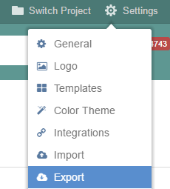
3. Click on- view your backup status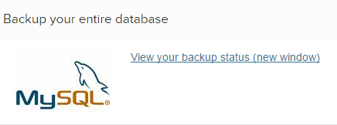
4. Click on- I’d like to create a new backup > Download
   1. Download the backup to your computer (this can take some time, don’t panic, just be patient)
   2. No need to change the name of the doc

**Part 2: Save the Backup to Google Drive**

1. Access Teamwork in Google Drive > SarahNoked.com > Sarah Noked Backups SN Teamwork Backups and upload the exported folder.

**Created by:**

**Department:** Operations & Support

**Date:**

**Revised:**

**Revised By:**